**CCCN221 – Computer Architecture**

**Lab 8 – Floating points in MIPS**

In this lab, we will go through Floating-Point Number Representation (IEEE 754 Standard), have the basic understanding of MIPS Floating-Point Unit. Will write down programs using the MIPS Floating-Point Instructions that will have the input and output as the floating point numbers.

Floating-Point Number Representation

Floating-point numbers have been defined as follows

|  |  |  |
| --- | --- | --- |
| **S** | **E = Exponent** | **F = Fraction** |

The Sign bit **S** is zero (positive) or one (negative).

For single-precision the Exponent field **E** has 8 bits and for double-precision, 11 bits. The exponent field is biased. The Biasis 127 for single-precision and 1023 for double-precision.

The Fraction field **F** is 23 bits for single-precision and 52 bits for double-precision. Floating-point numbers are normalized (except when **E** is zero). There is an implicit **1.** (not stored) before the fraction **F**. Therefore, the value of a normalized floating-point number is:

**Value =**  **(1.F)2 × 2 E – Bias**

The QTSPIM simulator has a floating-point representation tool that illustrates single-precision floating-point numbers. The figure 1 shows the floating point representation.

Now use the tool to check the binary format and the decimal value of floating-point numbers. For example, the decimal value of: **0 10000001 10110100000000000000000** is **6.75**.

Similarly, the 32-bit representation of: **-2.7531** is **1 10000000 01100000011001011001010**.

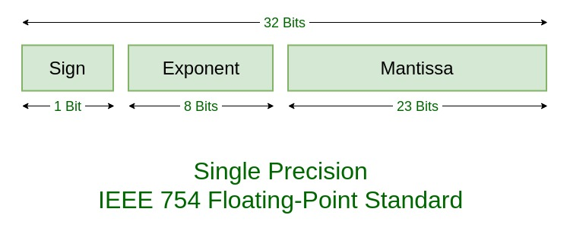

Figure 9.1: Floating-Point Representation

MIPS Floating-Point Registers

The floating-point unit (called coprocessor 1) has 32 floating-point registers. These registers are numbered as **$f0**, **$f1**, …, **$f31**. Each register is 32 bits wide. Thus, each register can hold one single-precision floating-point number. How can we use these registers to store 64-bit double- precision floating-point numbers? The answer is that the 32 single-precision registers are grouped into 16 double-precision registers. The double-precision number is stored in an even-odd pair of registers, but we only refer to the even-numbered register. For example, when we store a double- precision number in **$f0**, it is actually stored in registers **$f0** and **$f1**.

In addition, there are 8 condition flags, numbered from 0 to 7. These condition flags are used by floating-point compare and branch instructions. These are shown in Figure 9.2.

Figure 9.2: QTSPIM Floating-Point Registers and Condition Flags

MIPS Floating-Point Instructions

The FPU supports several instructions including floating-point load and store, floating-point arithmetic operations, floating-point data movement instructions, convert, and branch instructions. We start this section with the floating-point load and store instructions. These instructions load into or store a floating-point register. However, they use the same base-displacement addressing mode used with integer instructions. Notice that the base address register is an integer (not a floating- point) register.

|  |  |  |  |  |  |
| --- | --- | --- | --- | --- | --- |
| **Instruction** | | | **Example** | | **Meaning** |
| lwc1 | or | l.s | lwc1 | $f1,0($sp) | Load a word from memory to a single-precision floating-point register: $f1 = MEM[$sp] |
| ldc1 | or | l.d | ldc1 | $f2,8($t1) | Load a double word from memory to a double- precision register: $f2 = MEM[$t1+8] |

|  |  |  |  |  |  |
| --- | --- | --- | --- | --- | --- |
| **Instruction** | | | **Example** | | **Meaning** |
| swc1 | or | s.s | swc1 | $f5,4($t2) | Store a single-precision floating-point register in memory: MEM[$t2+4] = $f5 |
| sdc1 | or | s.d | sdc1 | $f6,16($t3) | Store a double-precision floating-point register in memory: MEM[$t3+16] = $f6 |

The floating-point arithmetic instructions are listed next. The **.s** extension is used for single- precision arithmetic instructions, while the **.d** is used for double-precision instructions.

|  |  |  |
| --- | --- | --- |
| **Instruction** | **Example** | **Meaning** |
| add.s | add.s $f0,$f2,$f4 | $f0 = $f2 + $f4 (single-precision) |
| add.d | add.d $f0,$f2,$f4 | $f0 = $f2 + $f4 (double-precision) |
| sub.s | sub.s $f0,$f2,$f4 | $f0 = $f2 - $f4 (single-precision) |
| sub.d | sub.d $f0,$f2,$f4 | $f0 = $f2 - $f4 (double-precision) |
| mul.s | mul.s $f0,$f2,$f4 | $f0 = $f2 × $f4 (single-precision) |
| mul.d | mul.d $f0,$f2,$f4 | $f0 = $f2 × $f4 (double-precision) |
| div.s | div.s $f0,$f2,$f4 | $f0 = $f2 / $f4 (single-precision) |
| div.d | div.d $f0,$f2,$f4 | $f0 = $f2 / $f4 (double-precision) |
| sqrt.s | sqrt.s $f0, $f2 | Square root (single-precision) |
| sqrt.d | sqrt.d $f0, $f2 | Square root (double-precision) |
| abs.s | abs.s $f0, $f2 | Absolute value (single-precision) |
| abs.d | abs.d $f0, $f2 | Absolute value (double-precision) |
| neg.s | neg.s $f0, $f2 | Negative value (single-precision) |
| neg.d | neg.d $f0, $f2 | Negative value (double-precision) |

The data movement instructions move data between general-purpose and floating-point registers, or between floating-point registers.

|  |  |  |
| --- | --- | --- |
| **Instruction** | **Example** | **Meaning** |
| mfc1 | mfc1 $t0, $f2 | Move data from a floating-point register to a general- purpose register. |
| mtc1 | mfc1 $t0, $f2 | Move data from a general-purpose register to a floating-point register. |
| mov.s | mov.s $f0, $f1 | Move single-precision data between two floating- point registers. |
| mov.d | mov.d $f0, $f2 | Move double-precision data between two floating- point registers (move even-odd pair of registers). |

The convert instructions convert the format of data in floating-point registers. Three data formats are supported: **.s** = single-precision float, **.d** = double-precision, and .w = integer word.

|  |  |  |
| --- | --- | --- |
| **Instruction** | **Example** | **Meaning** |
| cvt.s.w | cvt.s.w $f0,$f2 | **$f0** = convert **$f2** from word to single-precision |
| cvt.s.d | cvt.s.d $f0,$f2 | **$f0** = convert **$f2** from double to single-precision |
| cvt.d.w | cvt.d.w $f0,$f2 | **$f0** = convert **$f2** from word to double-precision |
| cvt.d.s | cvt.d.s $f0,$f2 | **$f0** = convert **$f2** from single to double-precision |
| cvt.w.s | cvt.w.s $f0,$f2 | **$f0** = convert **$f2** from single-precision to word |
| cvt.w.d | cvt.w.d $f0,$f2 | **$f0** = convert **$f2** from double-precision to word |
| ceil.w.s | ceil.w.s $f0,$f2 | **$f0** = Integer ceiling of single-precision float in **$f2** |
| ceil.w.d | ceil.w.d $f0,$f2 | **$f0** = Integer ceiling of double-precision float in **$f2** |
| floor.w.s | floor.w.s $f0,$f2 | **$f0** = Integer floor of single-precision float in **$f2** |
| floor.w.d | floor.w.d $f0,$f2 | **$f0** = Integer floor of double-precision float in **$f2** |
| trunc.w.s | trunc.w.s $f0,$f2 | **$f0** = Truncate single-precision float in **$f2** |
| trunc.w.d | trunc.w.d $f0,$f2 | **$f0** = Truncate double-precision float in **$f2** |

The floating-point compare instructions compare floating-point registers for equality, less than, and less than or equal. The FP compare instructions set the condition flags **0** to **7** to true (1) or false(0).

|  |  |  |
| --- | --- | --- |
| **Instruction** | **Example** | **Meaning** |
| c.eq.s | c.eq.s $f2,$f3 | if **($f2 == $f3)** set flag **0** to true else false |
| c.eq.d | c.eq.s 3,$f4,$f6 | Compare equal double-precision. Result in flag **3** |
| c.lt.s | c.eq.s 4,$f5,$f8 | if **($f5 < $f8)** set flag **4** to true else false |
| c.lt.d | c.lt.d 7,$f4,$f6 | Compare less-than double. Result in flag **7** |
| c.le.s | c.le.s $f10,$f11 | if **($f10 <= $f11)** set flag **0** to true else false |
| c.le.d | c.le.d $f14,$f16 | Compare less or equal double. Result in flag **0** |

The floating-point branch instructions (**bc1t** and **bc1f**) branch to the target address based on the value of the specified condition flag (true or false).

|  |  |  |
| --- | --- | --- |
| **Instruction** | **Example** | **Meaning** |
| bc1t | bc1t label | Branch to label if condition flag **0** is true |
| bc1t | bc1t 1, label | Branch to label if condition flag **1** is true |
| bc1f | bc1f label | Branch to label if condition flag **0** is false |
| bc1f | bc1f 4, label | Branch to label if condition flag **4** is false |

System Call Services for Floating-Point Numbers

The MARS tool provides the following **Syscall** service numbers (passed in **$v0**) to print and read single-precision and double-precision floating-point numbers:

|  |  |  |  |
| --- | --- | --- | --- |
| **Service** | **$v0** | **Arguments** | **Result** |
| Print Float | **2** | **$f12** = float to print |  |
| Print Double | **3** | **$f12** = double to print |  |
| Read Float | **6** |  | Float is returned in $f0 |
| Read Double | **7** |  | Double is returned in **$f0** |

MIPS Floating-Point Register Usage Convention

Compilers follow the MIPS register usage convention when translating functions and procedures into MIPS assembly-language code. The following table shows the MIPS software convention for floating-point registers. Not following the MIPS software usage convention can result in serious bugs when passing parameters, getting results, or using registers across function calls.

|  |  |
| --- | --- |
| **Registers** | **Usage** |
| $f0 - $f3 | Floating-point procedure results |
| $f4 - $f11 | Temporary floating-point registers, NOT preserved across procedure calls |
| $f12 - $f15 | Floating-point parameters, NOT preserved across procedure calls. Additional floating-point parameters should be pushed on the stack. |
| $f16 - $f19 | More temporary registers, NOT preserved across procedure calls. |
| $f20 - $f31 | Saved floating-point registers. Should be preserved across procedure calls. |

Contents

Lab Tasks 7

Task 1 7

Task 2 9

Task 3 9

Task 4 11

PICTURES OF THE CODE: 11

CODE: 12

Task 5 13

PICTURES OF THE CODE: 14

OUTPUTS 16

CODE: 17

Task 6 20

PICTURES OF THE CODE: 21

COMPARING RESULTS: 21

CODE: 22

# Lab Tasks

## Task 1

1. Convert by hand the number **-123456789** into its 32-bit single-precision binary representation, and Show your work for a full mark.

First. We start with the positive version of the number |-123456789| = 123456789

Second. We divide the number repeatedly by 2

division = quotient + remainder;

123 456 789 ÷ 2 = 61 728 394 + 1;

61 728 394 ÷ 2 = 30 864 197 + 0;

30 864 197 ÷ 2 = 15 432 098 + 1;

15 432 098 ÷ 2 = 7 716 049 + 0;

7 716 049 ÷ 2 = 3 858 024 + 1;

3 858 024 ÷ 2 = 1 929 012 + 0;

1 929 012 ÷ 2 = 964 506 + 0;

964 506 ÷ 2 = 482 253 + 0;

482 253 ÷ 2 = 241 126 + 1;

241 126 ÷ 2 = 120 563 + 0;

120 563 ÷ 2 = 60 281 + 1;

60 281 ÷ 2 = 30 140 + 1;

30 140 ÷ 2 = 15 070 + 0;

15 070 ÷ 2 = 7 535 + 0;

7 535 ÷ 2 = 3 767 + 1;

3 767 ÷ 2 = 1 883 + 1;

1 883 ÷ 2 = 941 + 1;

941 ÷ 2 = 470 + 1;

470 ÷ 2 = 235 + 0;

235 ÷ 2 = 117 + 1;

117 ÷ 2 = 58 + 1;

58 ÷ 2 = 29 + 0;

29 ÷ 2 = 14 + 1;

14 ÷ 2 = 7 + 0;

7 ÷ 2 = 3 + 1;

3 ÷ 2 = 1 + 1;

1 ÷ 2 = 0 + 1;

Then we Construct the base 2 representation of the positive number.

123 456 789 (decimal) = 111 0101 1011 1100 1101 0001 0101 (binary)

After that. We Normalize the binary representation of the number.

111 0101 1011 1100 1101 0001 0101 (binary) = 1.1101 0110 1111 0011 0100 0101 01 (binary) × $2^{26}$

Now. We adjust the exponent. Exponent (unadjusted) = 26

Exponent (adjusted) = Exponent (unadjusted) + 2(8-1) - 1 = 26 + 2(8-1) - 1 = (26 + 127)(10)

= 153(10)

Then we use the same technique by dividing the number repeatedly by 2

division = quotient + remainder;

153 ÷ 2 = 76 + 1;

76 ÷ 2 = 38 + 0;

38 ÷ 2 = 19 + 0;

19 ÷ 2 = 9 + 1;

9 ÷ 2 = 4 + 1;

4 ÷ 2 = 2 + 0;

2 ÷ 2 = 1 + 0;

1 ÷ 2 = 0 + 1;

Exponent (adjusted) = 153 (decimal) = 1001 1001 (binary)

After that. We normalized the mantissa by:

* A- Remove the leading bit
* B- Adjust its length to 23 by removing the excess bits

1.1101 0110 1111 0011 0100 0101 01 (binary) = 110 1011 0111 1001 1010 0010

Finally. The three elements that make up 32 bit single precision IEE 754 binary floating point are

Sign (1 bit) = 1

Exponent (8 bits) = 1001 1001 (binary)

Mantissa (23 bits) = 110 1011 0111 1001 1010 0010

= 1 10011001 11010110111100110100010

## Task 2

1. Convert by hand the floating-point number **1 10010100 1****0011000001100000000000** (shown in binary) into its corresponding decimal value. Show your work for a full mark.

Sign bit: 1 (negative)

Exponent: 10010100(binary) = 148 (decimal)

Mantissa: 10011000001100000000000 (binary)

First. we subtract 127 from the exponent to get the true exponent: 148 – 127 = 21

Second. we convert the mantissa to decimal, by multiplying by 2N of number:

1 × 2-1 + 0 × 2-2 + 0 × 2-3 + 1 × 2-4 + 1 × 2-5 + 0 × 2-6 + 0 × 2-7 + 0 × 2-8 + 0 × 2-9 + 0 × 2-10 + 1 × 2-11 + 1 × 2-12 + 0 × 2-13 + 0 × 2-14 + 0 × 2-15 + 0 × 2-16 + 0 × 2-17 + 0 × 2-18 + 0 × 2-19 + 0 × 2-20 + 0 × 2-21 + 0 × 2-22 + 0 × 2-23 = 0.594482421875 (decimal)

Then we will add 1 to the mantissa: 0.594482421875 (decimal) + 1 = 1.594482421875 (decimal)

Finally, the floating-point value is then equal to $-1×2^{21}×1.594482421875 = -3343872$

## Task 3

1. Trace the following program by hand to determine the values of registers **$f0** thru **$f9**. Notice that **array1** and **array2** have the same elements, but in a different order. Comment on the sums of **array1** and **array2** elements computed in registers **$f4** and **$f9**, respectively. Now use the QTSPIM tool to trace the execution of the program and verify your results. What conclusion can be made from this exercise?

.data

array1: .float 5.6e+20, -5.6e+20, 1.2

array2: .float 1.2, 5.6e+20, -5.6e+20

.text

.globl main

main:

la $t0, array1

lwc1 $f0, 0($t0)

lwc1 $f1, 4($t0)

lwc1 $f2, 8($t0)

add.s $f3, $f0, $f1

add.s $f4, $f2, $f3

la $t1, array2

lwc1 $f5, 0($t1)

lwc1 $f6, 4($t1)

lwc1 $f7, 8($t1)

add.s $f8, $f5, $f6

add.s $f9, $f7, $f8

li $v0, 10 # To terminate the program

syscall

.end main

$f0 = 5.6e+20

$f1 = -5.6e+20

$f2 = 1.2

$f3 = $f0 + $f1 = 0

$f4 = $f2 + $f3 = 1.2

$f5 = 1.2

$f6 = 5.6e+20

$f7 = -5.6e+20

$f8 = $f5 + $f6 = 5.6e+20

$f9 = $f7 + $f8 = 0

The sum of elements of "array1" is 1.2 and the sum of elements of "array2" is 0. This shows that the order of elements in a floating-point addition operation can affect the result due to the limited precision of floating-point numbers.

## Task 4

1. Write an interactive program that inputs an integer **sum** and an integer **count**, computes, and displays the **average** **=** **(float)** **sum** **/** **(float)** **count** as a single-precision floating- point number. Hint: use the proper convert instruction to convert **sum** and **count** from integer word into single-precision float.

### PICTURES OF THE CODE:

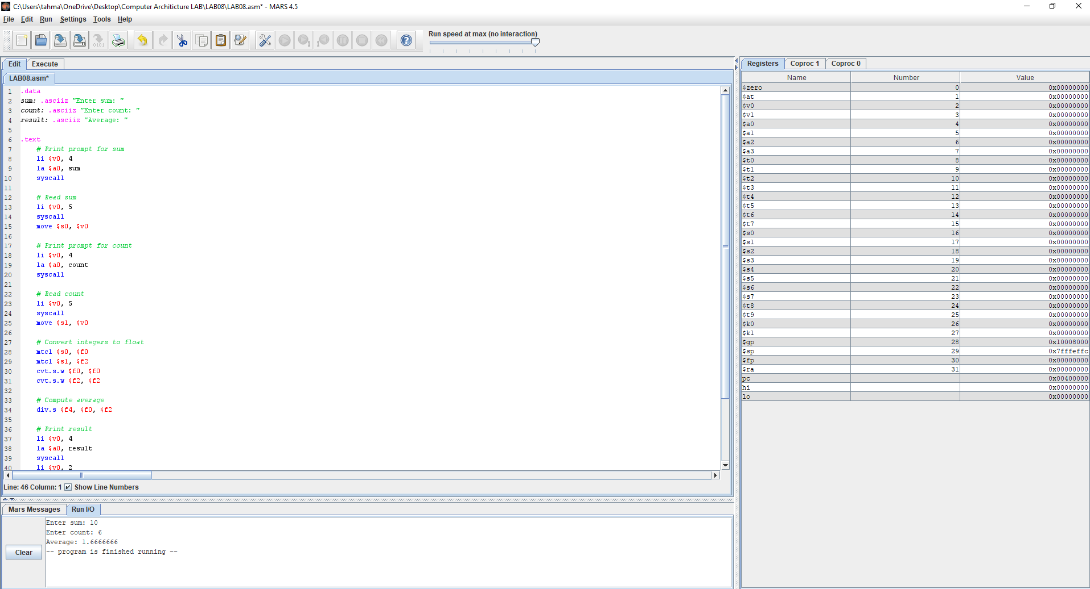

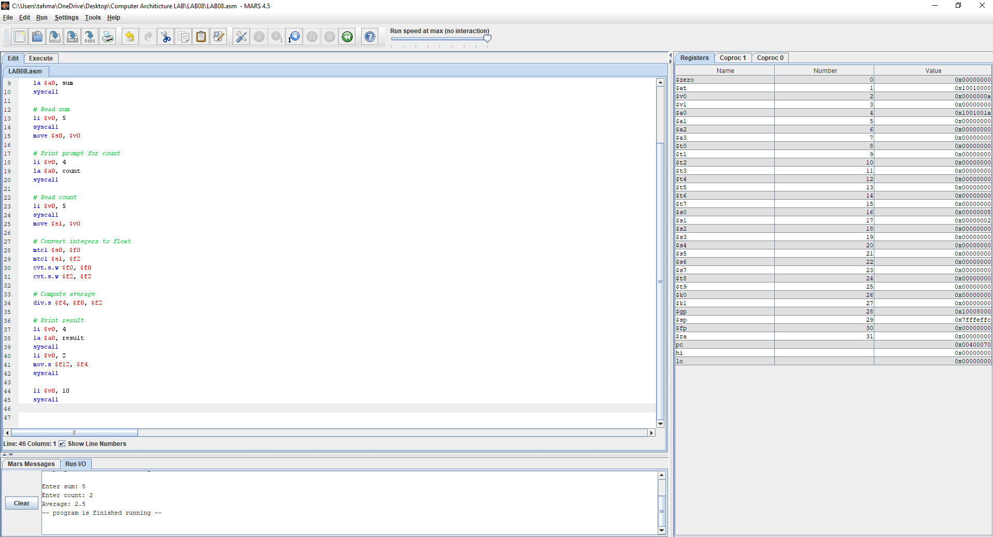

### CODE:

.data

sum: .asciiz "Enter sum: "

count: .asciiz "Enter count: "

result: .asciiz "Average: "

.text

# Print prompt for sum

li $v0, 4

la $a0, sum

syscall

# Read sum

li $v0, 5

syscall

move $s0, $v0

# Print prompt for count

li $v0, 4

la $a0, count

syscall

# Read count

li $v0, 5

syscall

move $s1, $v0

# Convert integers to float

mtc1 $s0, $f0

mtc1 $s1, $f2

cvt.s.w $f0, $f0

cvt.s.w $f2, $f2

# Compute average

div.s $f4, $f0, $f2

# Print result

li $v0, 4

la $a0, result

syscall

li $v0, 2

mov.s $f12, $f4

syscall

li $v0, 10

syscall

## Task 5

1. Write an interactive program that inputs the coefficient of a quadratic equation, computes, and displays the roots of the quadratic equation. All input, computation, and output should be done using double-precision floating-point instructions and registers. The program should handle the case of complex roots and displays the results properly.

$$x=-b±\frac{\sqrt{b^{2}-4ac}}{2a}$$

### PICTURES OF THE CODE:

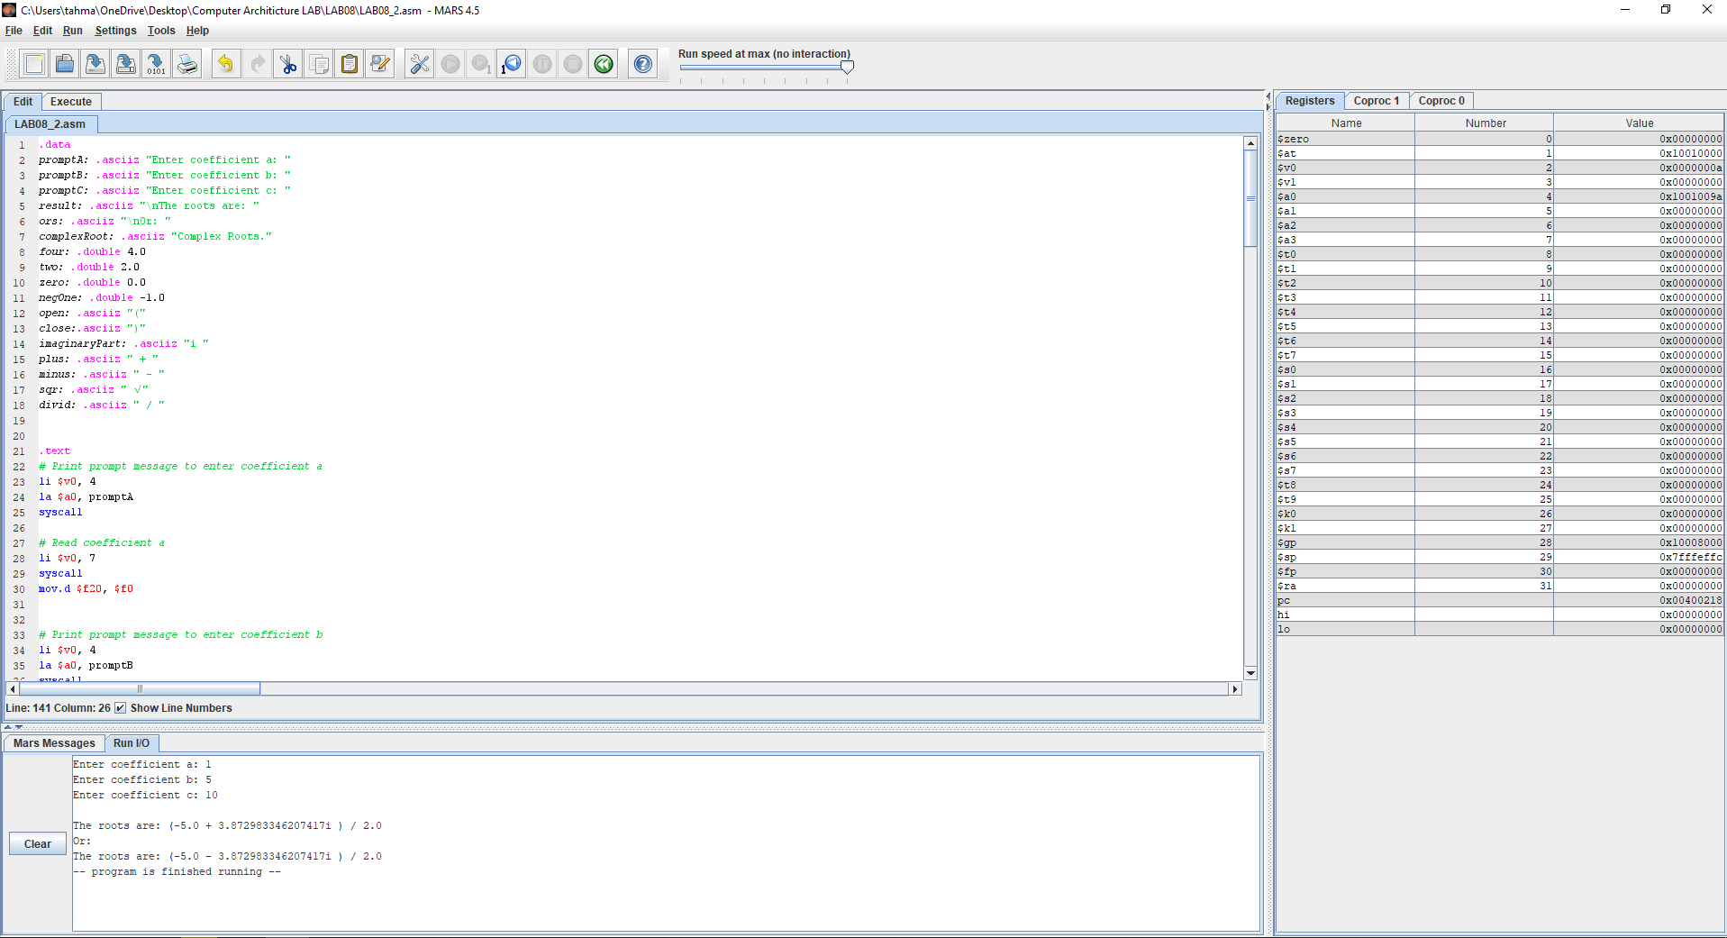

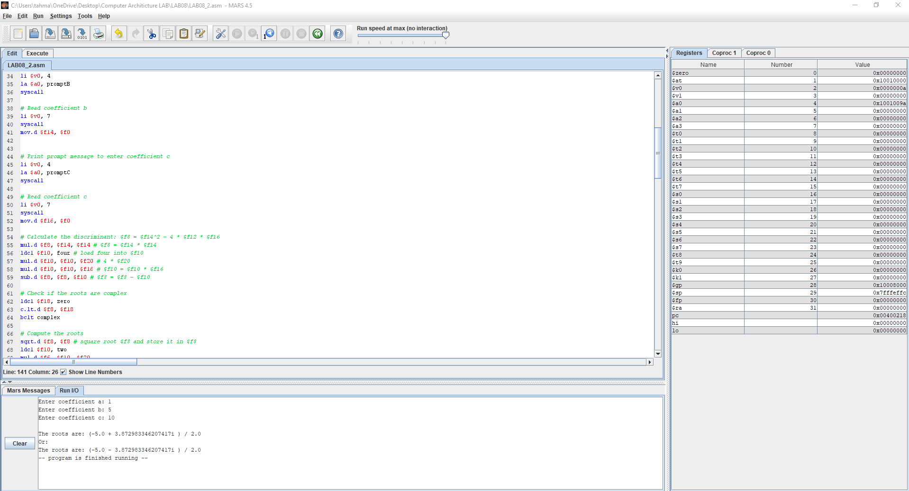

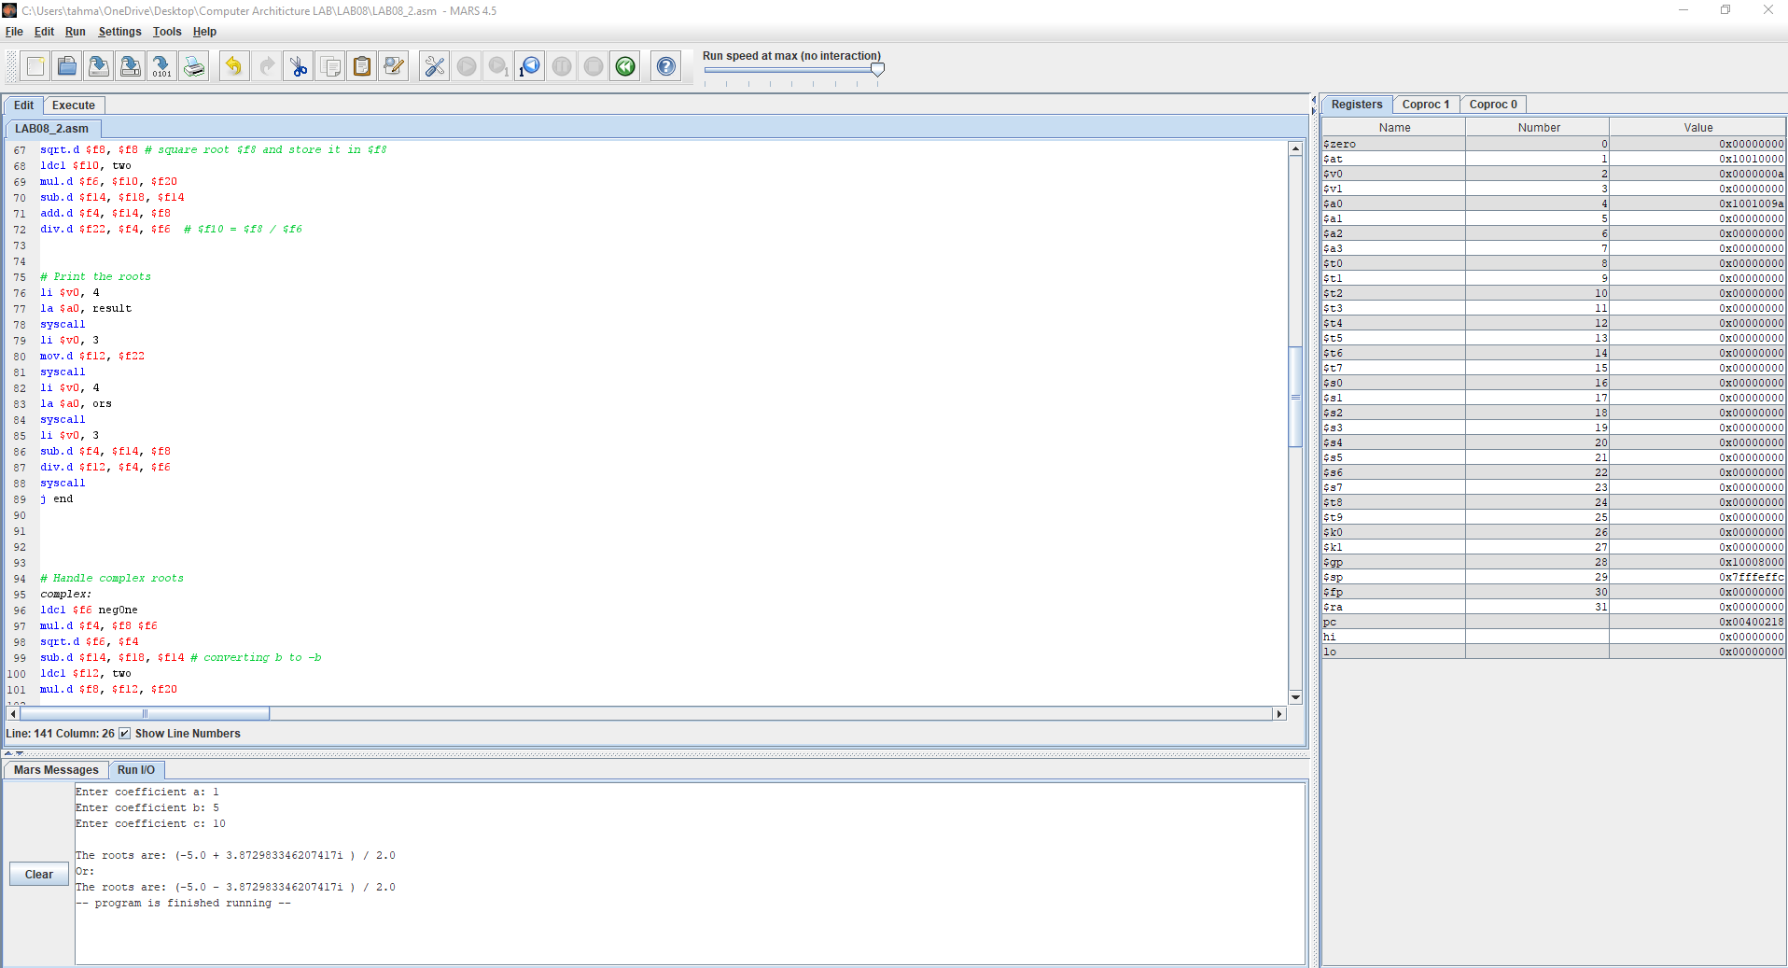

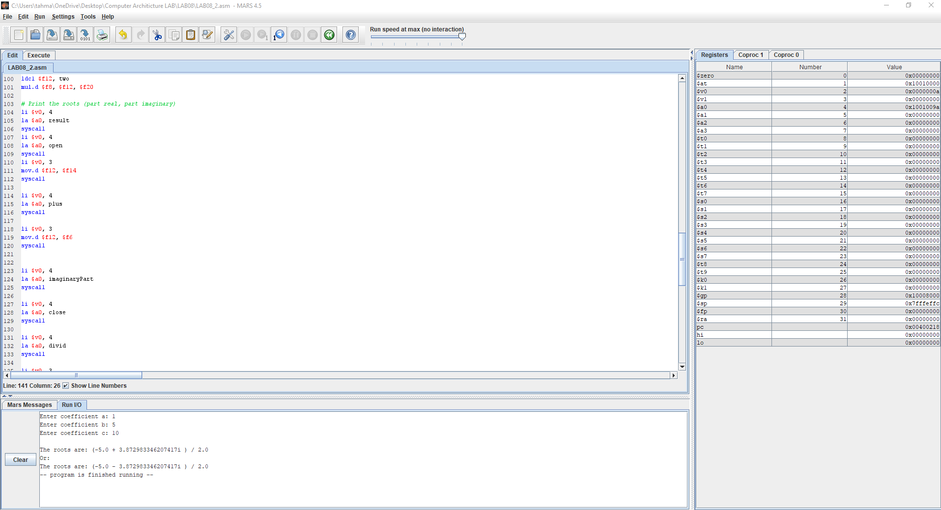 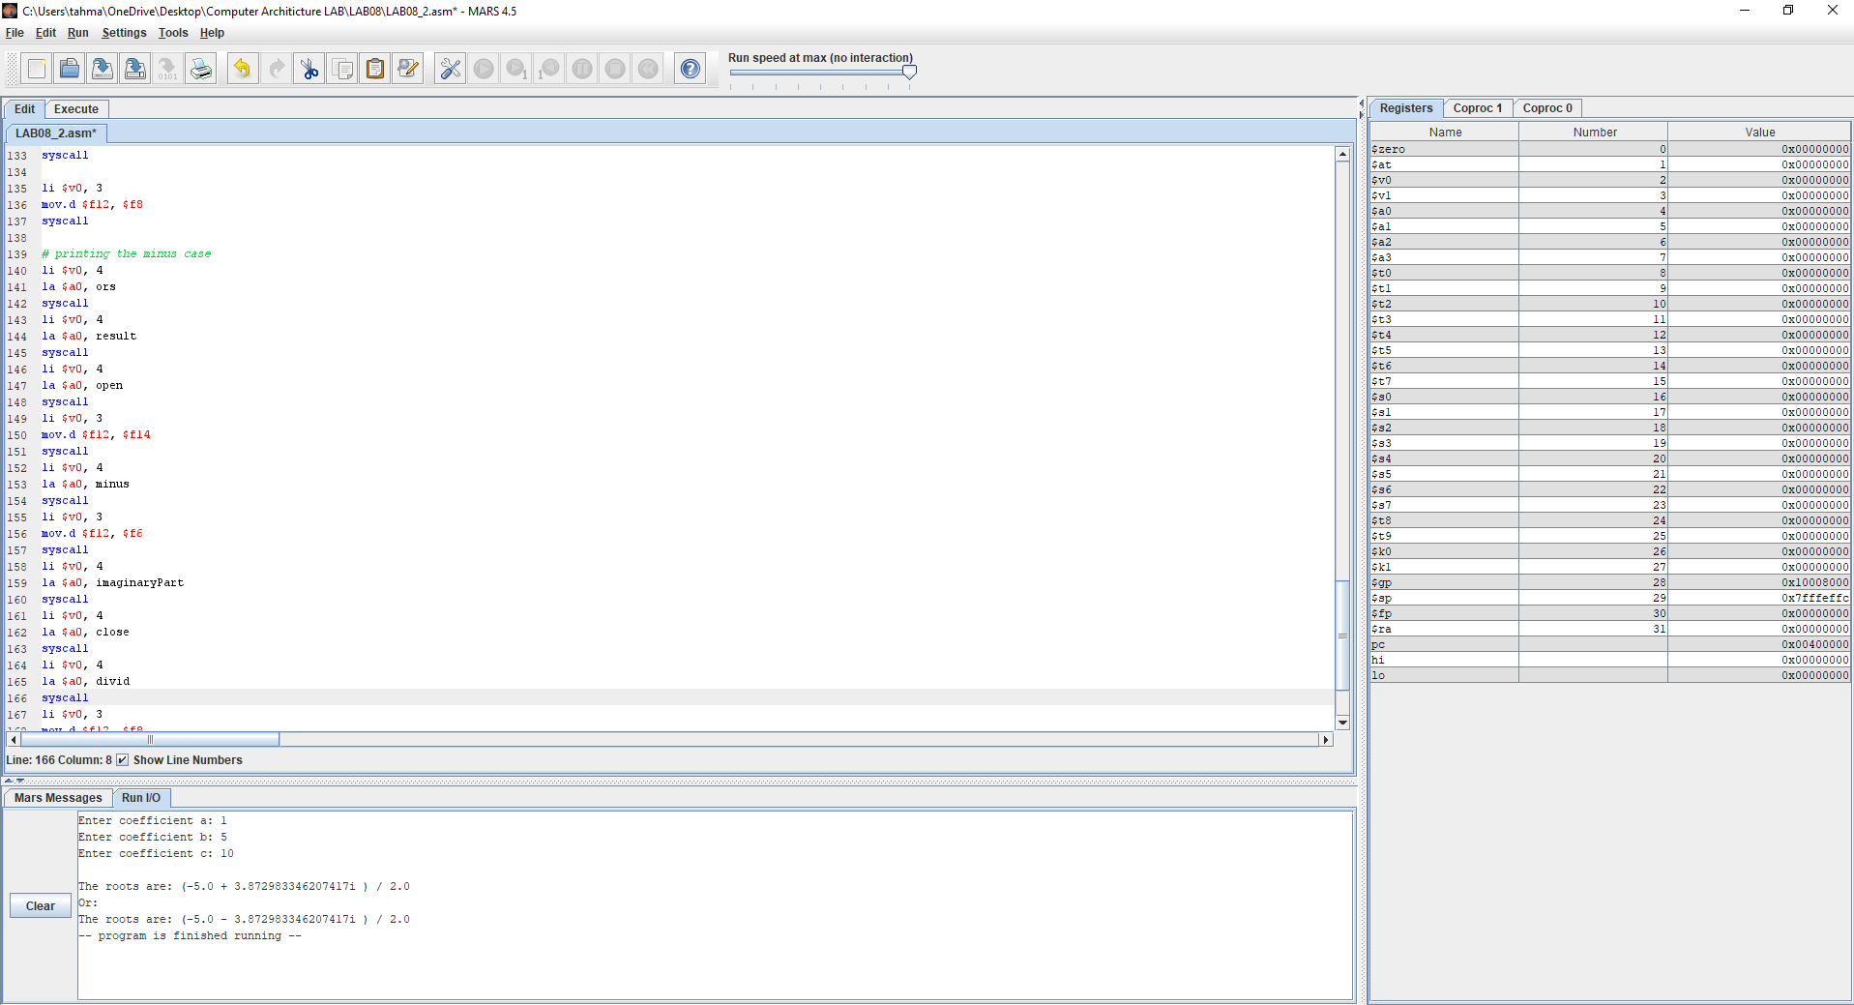

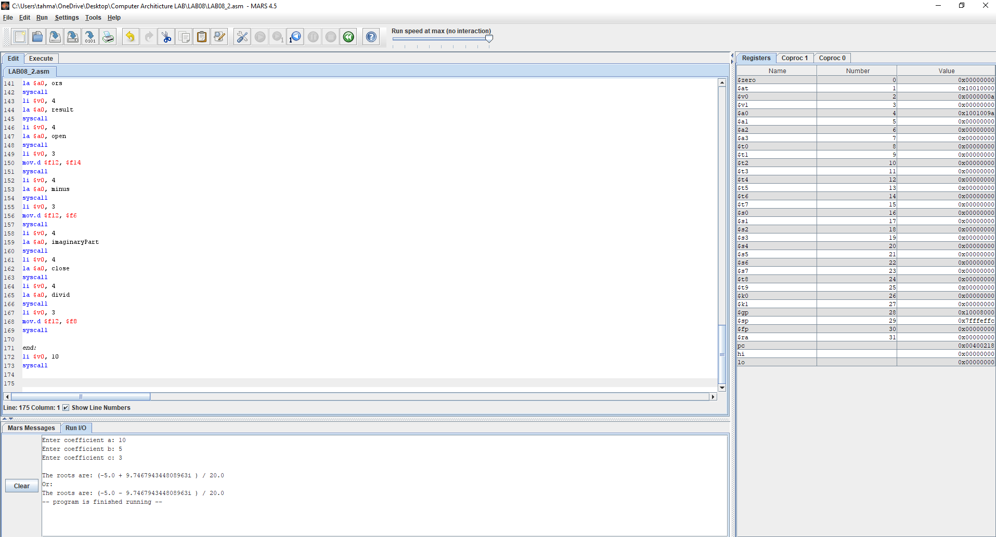

### OUTPUTS

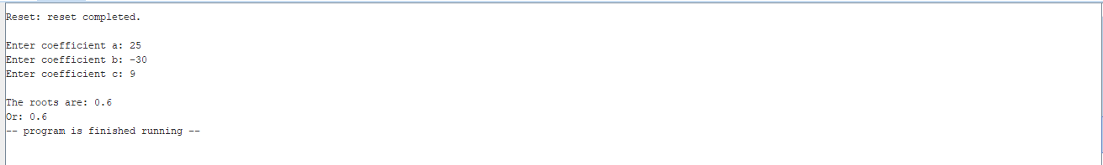

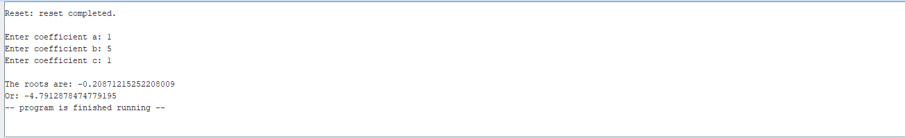

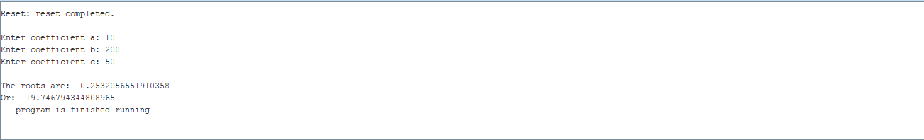

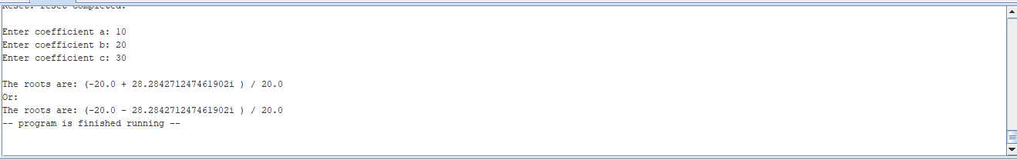

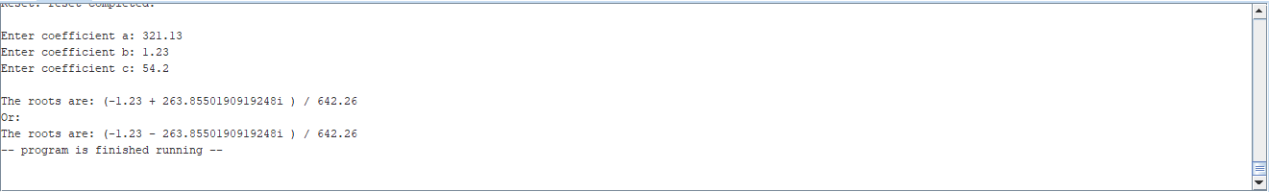

### CODE:

.data

promptA: .asciiz "Enter coefficient a: "

promptB: .asciiz "Enter coefficient b: "

promptC: .asciiz "Enter coefficient c: "

result: .asciiz "\nThe roots are: "

ors: .asciiz "\nOr: "

complexRoot: .asciiz "Complex Roots."

four: .double 4.0

two: .double 2.0

zero: .double 0.0

negOne: .double -1.0

open: .asciiz "("

close:.asciiz ")"

imaginaryPart: .asciiz "i "

plus: .asciiz " + "

minus: .asciiz " - "

sqr: .asciiz " √"

divid: .asciiz " / "

.text

# Print prompt message to enter coefficient a

li $v0, 4

la $a0, promptA

syscall

# Read coefficient a

li $v0, 7

syscall

mov.d $f20, $f0

# Print prompt message to enter coefficient b

li $v0, 4

la $a0, promptB

syscall

# Read coefficient b

li $v0, 7

syscall

mov.d $f14, $f0

# Print prompt message to enter coefficient c

li $v0, 4

la $a0, promptC

syscall

# Read coefficient c

li $v0, 7

syscall

mov.d $f16, $f0

# Calculate the discriminant: $f8 = $f14^2 - 4 * $f12 * $f16

mul.d $f8, $f14, $f14 # $f8 = $f14 * $f14

ldc1 $f10, four # load four into $f10

mul.d $f10, $f10, $f20 # 4 * $f20

mul.d $f10, $f10, $f16 # $f10 = $f10 * $f16

sub.d $f8, $f8, $f10 # $f8 = $f8 - $f10

# Check if the roots are complex

ldc1 $f18, zero

c.lt.d $f8, $f18

bc1t complex

# Compute the roots

sqrt.d $f8, $f8 # square root $f8 and store it in $f8

ldc1 $f10, two

mul.d $f6, $f10, $f20

sub.d $f14, $f18, $f14

add.d $f4, $f14, $f8

div.d $f22, $f4, $f6 # $f10 = $f8 / $f6

# Print the roots

li $v0, 4

la $a0, result

syscall

li $v0, 3

mov.d $f12, $f22

syscall

li $v0, 4

la $a0, ors

syscall

li $v0, 3

sub.d $f4, $f14, $f8

div.d $f12, $f4, $f6

syscall

j end

# Handle complex roots

complex:

ldc1 $f6 negOne

mul.d $f4, $f8 $f6

sqrt.d $f6, $f4

sub.d $f14, $f18, $f14 # converting b to -b

ldc1 $f12, two

mul.d $f8, $f12, $f20

# Print the roots (part real, part imaginary)

li $v0, 4

la $a0, result

syscall

li $v0, 4

la $a0, open

syscall

li $v0, 3

mov.d $f12, $f14

syscall

li $v0, 4

la $a0, plus

syscall

li $v0, 3

mov.d $f12, $f6

syscall

li $v0, 4

la $a0, imaginaryPart

syscall

li $v0, 4

la $a0, close

syscall

li $v0, 4

la $a0, divid

syscall

li $v0, 3

mov.d $f12, $f8

syscall

# printing the minus case

li $v0, 4

la $a0, ors

syscall

li $v0, 4

la $a0, result

syscall

li $v0, 4

la $a0, open

syscall

li $v0, 3

mov.d $f12, $f14

syscall

li $v0, 4

la $a0, minus

syscall

li $v0, 3

mov.d $f12, $f6

syscall

li $v0, 4

la $a0, imaginaryPart

syscall

li $v0, 4

la $a0, close

syscall

li $v0, 4

la $a0, divid

syscall

li $v0, 3

mov.d $f12, $f8

syscall

end:

li $v0, 10

syscall

## Task 6

1. Square Root Calculation: Newton’s iterative method can be used to approximate the square root of a number **x**. Let the initial **guess** be **1**. Then each new **guess** can be computed as follows:

**guess** **=** **((x/guess)** **+** **guess)** **/** **2;**

Write a function called **square_root** that receives a double-precision parameter **x**, computes, and returns the approximated value of the square root of **x**. Write a loop that repeats 20 times and computes 20 **guess** values, then returns the final **guess** after 20 iterations. Use the MIPS floating-point register convention to pass the parameter **x** and to return the function result. All computation should be done using double-precision floating-point instructions and registers. Compare the result of the **sqrt.d** instruction against the result of your **square_root** function. What is the error in absolute value?

### PICTURES OF THE CODE:

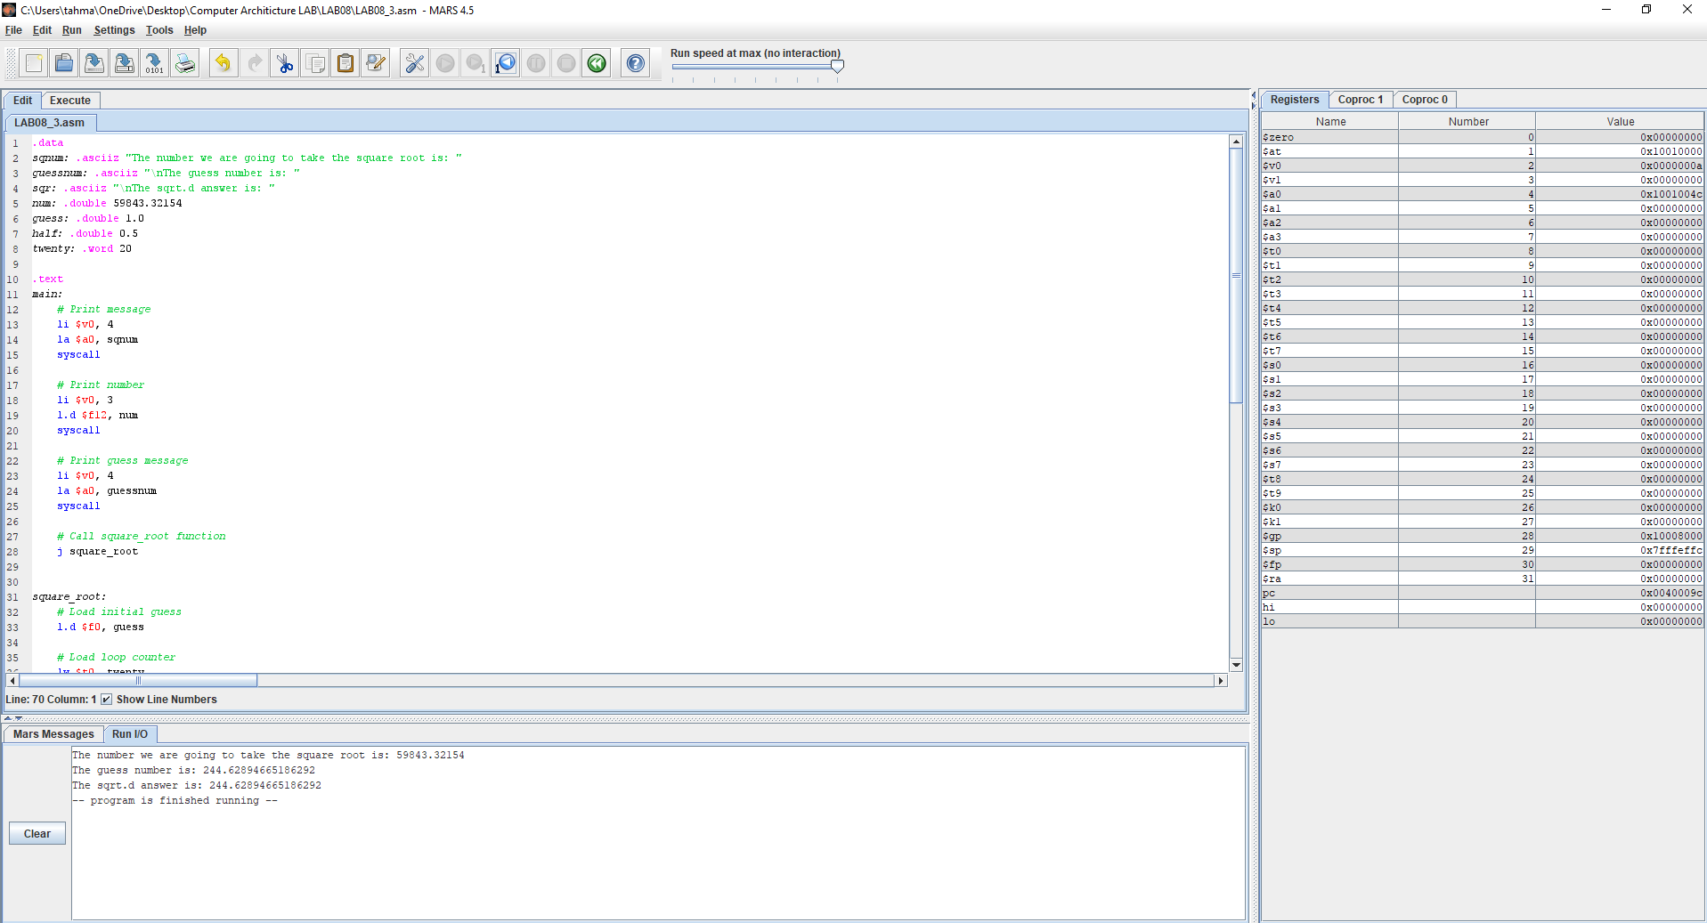

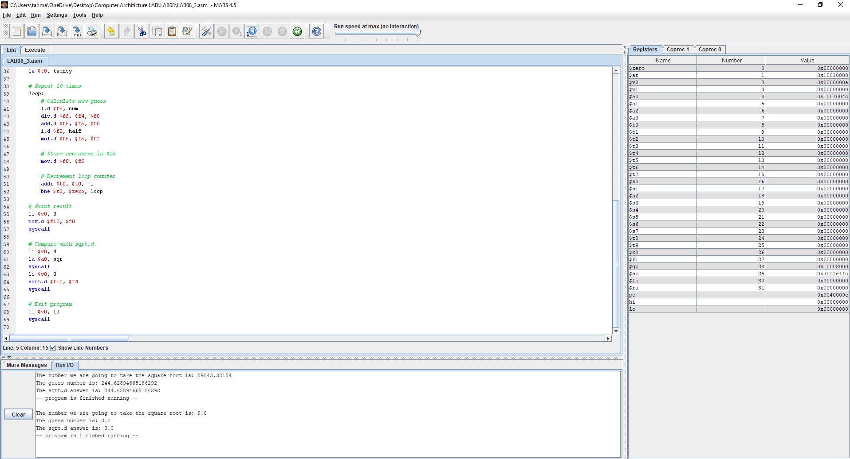

### COMPARING RESULTS:

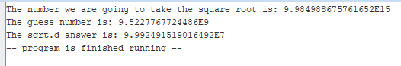

Error = 9.5227767724486E9 - 9.992491519016492E7 = 852929148061692

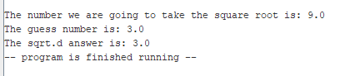

Error = 3.0 – 3.0 = 0.0

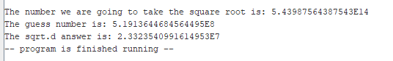

Error = 2.3323540991614953E7 - 5.1913644684564495E8 = 4.85801037029501E8

The difference gets bigger when the number is big. We can fix that by increasing the loops from 20 to something bigger.

### CODE:

.data

sqnum: .asciiz "The number we are going to take the square root is: "

guessnum: .asciiz "\nThe guess number is: "

sqr: .asciiz "\nThe sqrt.d answer is: "

num: .double 5.43987564387543E14

guess: .double 1.0

half: .double 0.5

twenty: .word 20

.text

main:

# Print message

li $v0, 4

la $a0, sqnum

syscall

# Print number

li $v0, 3

l.d $f12, num

syscall

# Print guess message

li $v0, 4

la $a0, guessnum

syscall

# Call square_root function

j square_root

square_root:

# Load initial guess

l.d $f0, guess

# Load loop counter

lw $t0, twenty

# Repeat 20 times

loop:

# Calculate new guess

l.d $f4, num

div.d $f6, $f4, $f0

add.d $f6, $f6, $f0

l.d $f2, half

mul.d $f6, $f6, $f2

# Store new guess in $f0

mov.d $f0, $f6

# Decrement loop counter

addi $t0, $t0, -1

bne $t0, $zero, loop

# Print result

li $v0, 3

mov.d $f12, $f0

syscall

# Compare with sqrt.d

li $v0, 4

la $a0, sqr

syscall

li $v0, 3

sqrt.d $f12, $f4

syscall

# Exit program

li $v0, 10

syscall